JK 3.2 meter Large Format ECO solvent Printer 1440dpi
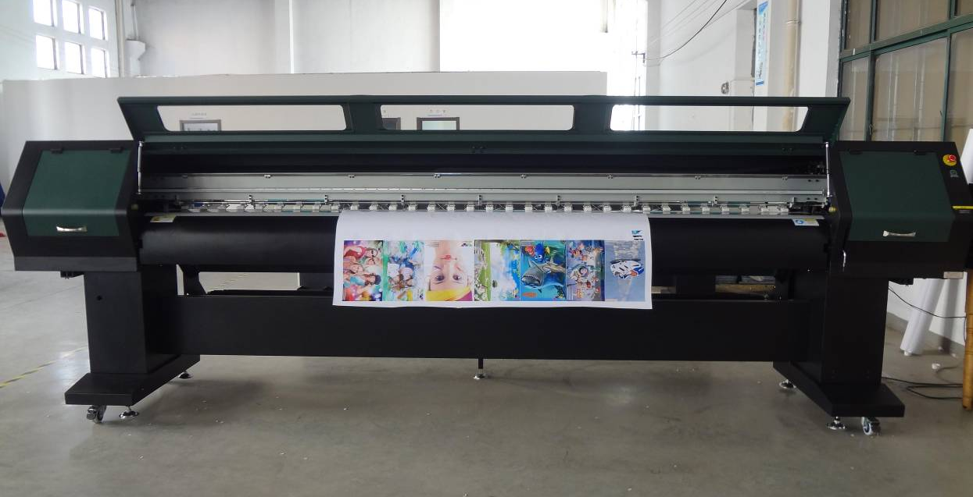

Specification |  | Parameters
Print Head | Type of Print Head | Piezoelectric Print Head
Print Head | Quantity | 2
Inks | Ink’s Color | 4 X 4 Colour C, M, Y, K
Inks | Ink’s Type | Piezoelectric DX5 Eco solvent Inks
Inks | Way of Supply Inks | Automatic Ink Supply
Speed | Production Model | 43 ㎡/h
Speed | Precision Model | 37 ㎡/h
Speed | High Precision Model | 29 ㎡/h
Heating & Drying | Heating & Drying | Front, Middle and Rear Plus Fans
Heating & Drying | Temperature | Normal Temperature 80℃，Suggestion Temperature:40-60℃
Media | Media Size | 3200mm
Media | Media Type | High Glossy Photo Paper, PP, Light Sheet, Oil Painting Paper and other Medias suitable for Water Based Printing Medias
Media | Media Transfer | Automatic High Precision Feeding, Take Up System
Print Head Cleaning |  | Automatic Cleaning Device and Automatic Scraping Device
Interface |  | USB
Working Temperature |  | Temperature: 18-29℃, Humidity: 550-80%
Power |  | 50 Hz AC220V()
Software |  | Main Top / Photo Print
Dimension |  | Length X Width X Height (mm): 4660 X 960 X 1250
Weight |  | 600KG

